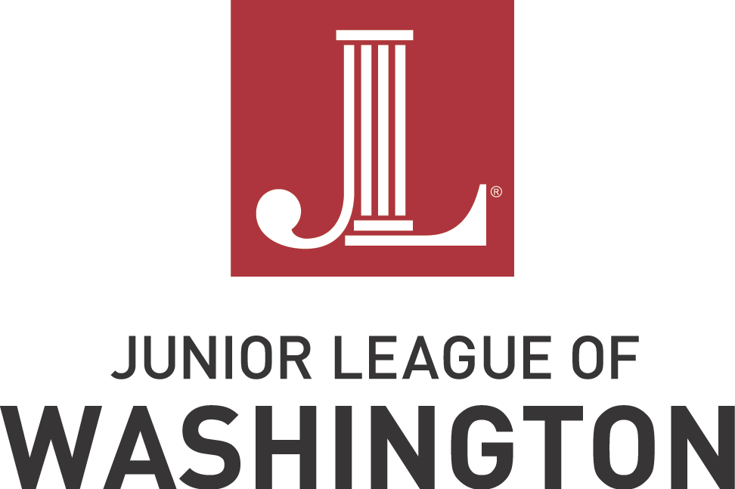

Community Assistance Grant Application

The Junior League of Washington (JLW) established the Community Assistance Fund (CAF) in 2019 to support nonprofit organizations in the greater Washington, DC, area experiencing urgent need for how they provided community support as a result of the COVID-19 public health emergency. In 2022, the CAF expanded its reach to assist community nonprofits experiencing any kind of emergency need. Grants will be awarded in amounts up to $5,000.

Applications for Community Assistance Grants will be accepted beginning on Monday, February 27th and must be submitted no later than Sunday, March 12th at 5pm EST via the webform on http://www.JLW.org/grants.

For consideration for any Junior League of Washington grant, an applicant must:
• Be a 501(c)3 organization with a valid EIN number;
• Be located in the greater Metropolitan Washington, D.C. area;
• Present a program in alignment with JLW’s mission, specifically “improving communities through […] effective action”;
• Address a clear unmet need within the organization and/or the community; and
• Demonstrate that JLW funds will have a significant financial impact.

For consideration for a Community Assistance Grant, in particular, applicant organizations must be experiencing an urgent financial need related to how they provide community support. Preference will be given to organizations that:
- Are experiencing a surge in demand for their services;
- Lost access to a key supplier, resulting in an increase in costs;
- Suffered property damage or had a piece of equipment break;
- Had a fundraising event cancelled due to external forces; or
- Experienced another unanticipated difficulty that has resulted in unexpected need.

This year, funding preference will be given to organizations/programs addressing housing insecurity and homelessness. However, organizations serving all areas of community need are eligible for funding and are encouraged to apply.

Organizations that receive a JLW Community Assistance Grant within the present League year (June 1, 2022 – May 31, 2023) are ineligible to apply for additional Community Assistance Grants within the same year.

Successful applicants will be notified on Tuesday, April 4th. Please note that recipients of the Community Assistance Grant must spend funds within 30 days of fund receipt and submit a grant report no later than 45 days after the award letter date.

INTRODUCTORY INFORMATION:
Legal Business Name: As shown on 501(c)(3) letter | Valid Employer Identification Number (EIN):
Website Address:  Organization City, State: | Total Funds Being Requested: Maximum $5,000

APPLICATION CHECKLIST
To submit your application, complete all fields of the web form, the application narrative, and include the required appendices listed below. Applications must be submitted via the web form no later than March 12th at 5 pm EST. Late or incomplete applications will not be accepted. Please email questions to GrantsAndVolunteers@JLW.org Successful applicants will be notified on April 4th.

Check each item on the list below to indicate that you have included the following appendices in your application before submitting your completed application via the web form. Please adhere to the naming convention before uploading each document individually.

A. Application Checklist and Narrative
- Save as: “Organization Acronym or name.CAG23” (For example: “JLW.CAG23”)
B. Letter from the Internal Revenue Service stating your organization is tax-exempt under Section 501(c)(3) of the Internal Revenue Code and is classified as “not a private foundation” under Section 509(a) of the same code
- Save as: “Organization Acronym or name.501c3” (For example: “JLW.501c3”)

C. Most recently filed Form 990
- Save as: “Organization Acronym or name.990” (For example: “JLW.990”)
D. Most recent audited financial statements and the management letter
- Save as: “Organization Acronym or name.FS” (For example: “JLW.FS”)

E. Current annual budget
- Save as: “Organization Acronym or name.AB” (For example: “JLW.AB”)

F. Current program budget
- Save as: “Organization Acronym or name.PB” (For example: “JLW.PB”)

If any of the information on the checklist is not available for your organization, please explain below:

SIGNATURE OF EXECUTIVE DIRECTOR OR PRESIDENT OF THE BOARD:
The signature is mandatory. Applications without the proper signature will not be accepted.

_________________________________________________ ________
SIGNATURE DATE

_________________________________________________ ________
TITLE PHONE NUMBER

__________________________________________________
EMAIL ADDRESS
APPLICATION NARRATIVE
All responses are limited to 500 words.
Give a brief summary of your organization’s mission, activities, and service population(s).

Describe your emergency situation and how it has affected your daily operations.

Detail your request for financial assistance: How will funds be spent? How many people will the funds serve? How quickly will you spend the funds? How will you measure the effectiveness of the funds’ use?

Specify how your organization will spend the Community Assistance Grant (maximum $5,000) by giving details about the key line-item expenditures you have planned. Please be specific when describing the amount and use of funding.
EXPENSE | QUANTITY | TOTAL COST | JLW CAFG Portion
EXAMPLE: Mold remediation following facility flooding provided by ACME Mold Co. | 3 days of professional mold remediation services | $3,500 | $3,500

